To: NEA

From: GBAO

Date: June 14, 2021

Member Tracking Poll: COVID-19 Vaccine And School Reopening

NEA and GBAO have been tracking vaccination rates among NEA members since February. Our most recent May tracking poll of NEA members shows that the vast majority of members have now been fully vaccinated, a massive 62-point increase from two months ago. A growing number of members say the vaccine makes them feel safer about working in-person.

Just 3 percent of members are now in full distance learning, down from 20 percent in March. Members continue to want their schools to address ventilation. Ventilation is the second most important safety measure for members, but just a third of members say their school’s ventilation system is providing them enough protection, and many are uncertain of their ventilation quality.

The following are key findings from a nationwide poll of 2,690 educators who are members of the National Education Association.

Key Findings

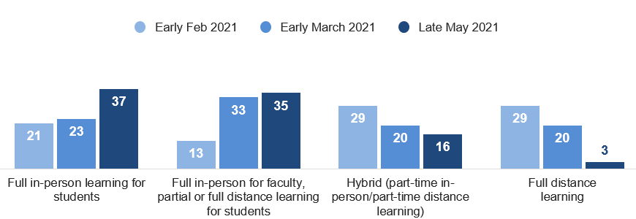
- The vast majority of members are now working in school buildings; students mixed between hybrid and full in-person instruction. Most members (72 percent) are working full-time in-person at their schools, while 37 percent of students are full-time in-person. The remaining members are doing hybrid instruction, and only 3 percent are doing full virtual instruction.

- There has been a massive increase in the percent of members vaccinated. Most members (86 percent) have received at least one dose of a COVID-19 vaccine, compared to 49 percent a month ago. Additionally, 3 percent have scheduled their vaccination, 9 percent say they will not be vaccinated, and 2 percent are not sure whether they get vaccinated.

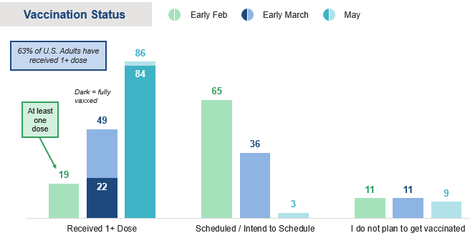

- A growing number of members feel safer about in-person instruction. Most members said the vaccine has made them feel safer (73 percent) about working in-person instruction during the pandemic, a slight increase from two months ago

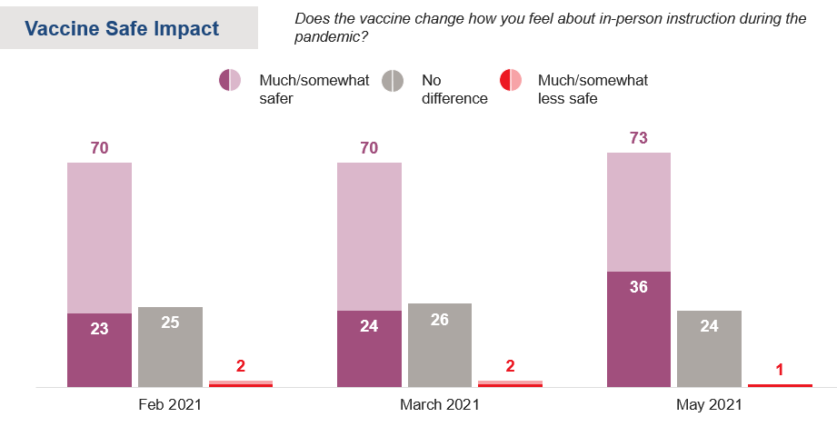

The vast majority of members are ready for full-time in-person instruction, while others will return if required.

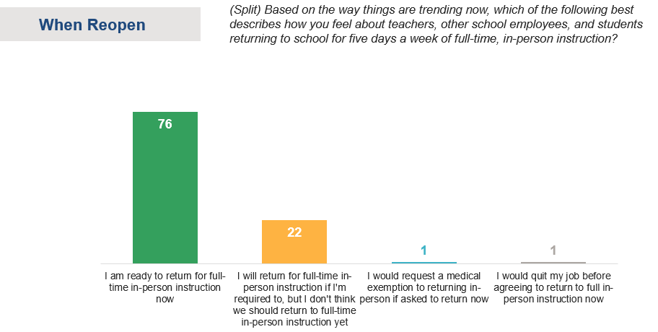

- The pandemic has taken a toll on educators. One-third of members report plans to leave education sooner than planned as a result of the pandemic. While later-career members are more likely to say that they plan to leave the profession or retire early, this survey finds that nearly a third (29%) of early career members say they will leave the profession as a result of the pandemic. This could exacerbate an existing teacher shortage.

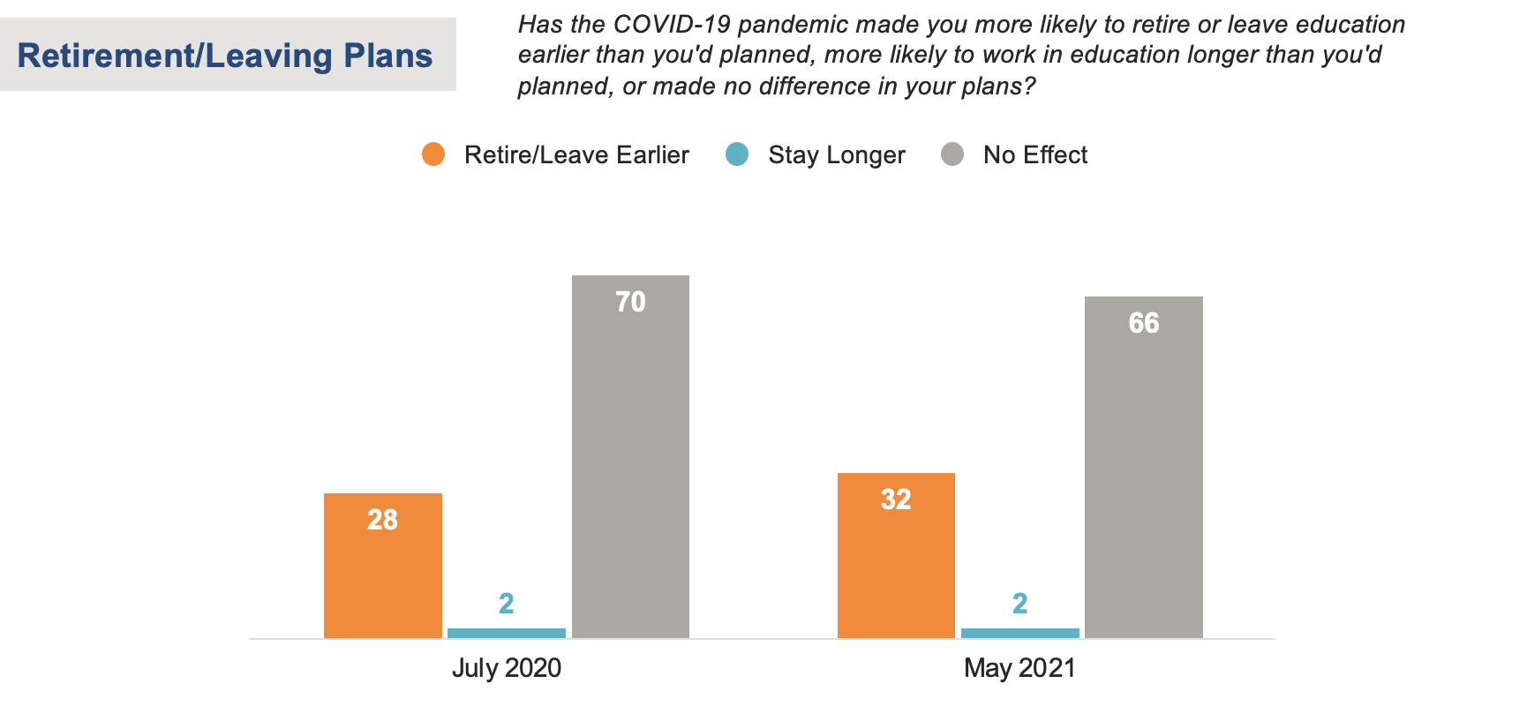

- Members say improved ventilation in school buildings is a top priority, though only a third report it implemented in their schools. Requiring PPE and enforcing physical distancing for in-person instruction is less important to members now than it was two months ago. While members still favor a wide range of proposals to make school buildings safer, including requiring staff and students to isolate if they test positive, having sanitizer available, and cleaning schools regularly – there’s been a significant drop in other measures like requiring PPE and enforcing physical distancing measures. Among members whose schools are providing at least some in-person instruction, most say these protocols are currently in place in their schools, with the exception of improved ventilation systems – which only 35 percent say is instituted in their school (up from 28 percent in March).

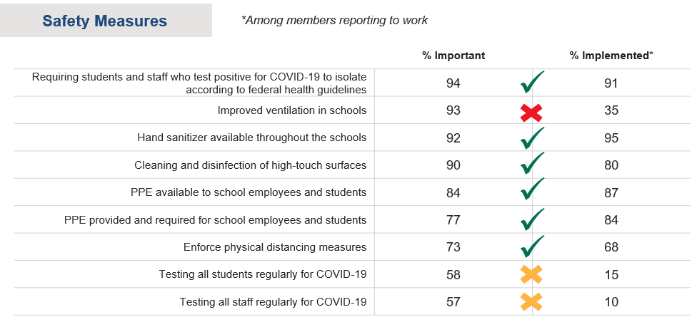

When directly asked whether they think their school’s ventilation system is providing them enough protection from COVID-19 to feel safe working in-person, 34 percent say yes, 38 percent say no, and 28 percent aren’t sure.

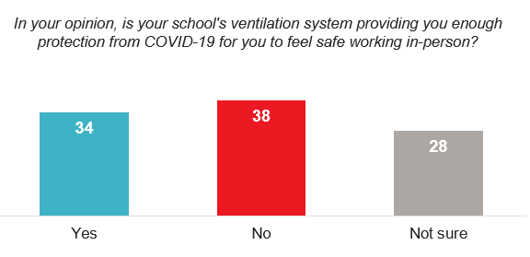

- Many members are uncertain of changes their schools are making next year to address post-pandemic needs. With other polling illustrating that academic loss is a concern among the public and parents, only 23 percent of members say their schools are implementing or considering implementing more one-on-one tutoring opportunities for students next year, 27 percent say there are no plans for more tutoring, and 50 percent are not sure. Additionally, only one-third of members know their schools are doing something to address educator mental health, 41 percent are not sure.

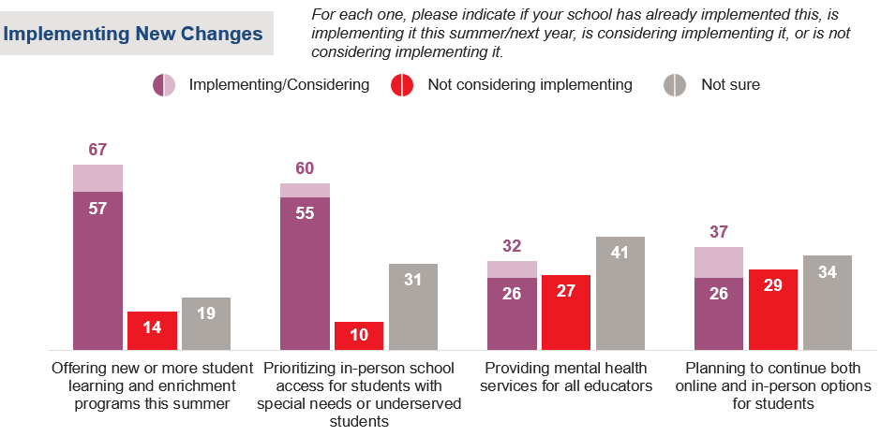
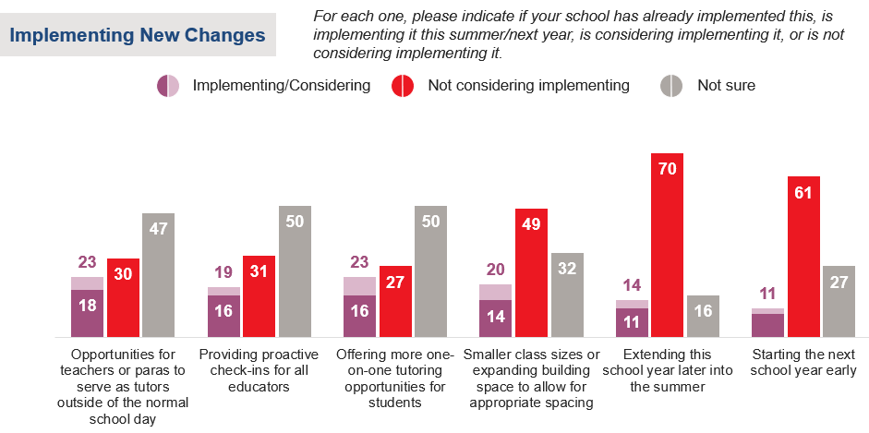

Methodology

On behalf of the National Education Association, GBAO conducted the nationally representative online survey of 2,690 non-retired NEA members May 19-26, 2021. The sample is subject to a +/- 1.9 percentage point margin of error at the 95 percent confidence level.

