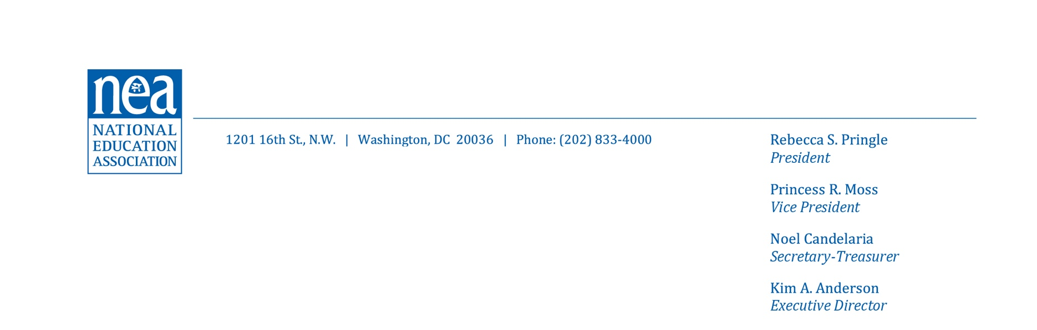

July 24, 2024

United States Senate

Washington, DC 20510

Dear Senator:

On behalf of our 3 million members and the 50 million students they serve, we urge you to VOTE YES on the Kids Online Safety and Privacy Act that is expected to be considered this week. Votes on this issue may be included in NEA’s report card for the 118th Congress.

NEA members have voiced broad support for federal and state governments requiring social media companies to make changes to protect student safety and privacy, amid rising concerns over students’ mental health and negative impacts of social media, such as bullying, eating disorders, sexual exploitation, and other potential harms.

We appreciate the bipartisan efforts of senators to work to address educators’ concerns, as well as those of parents. We understand this week’s vote is on a combination of two bills. The Kids Online Safety Act would create a “duty of care” for companies to design their social media platforms to mitigate harms, to protect privacy and personal data, disable addictive online features, permit opting out of personalized algorithmic recommendations, and provide parents with more options and safeguards to help protect their children. The update to the Children and Teens’ Privacy and Protection Act (COPPA 2.0) builds on existing privacy protections, updates the ages covered from 13 to 16, and would block targeted advertising for children and teens.

We urge you to VOTE YES on these measures.

Sincerely,

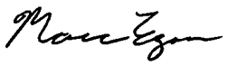

Marc Egan

Director of Government Relations

National Education Association