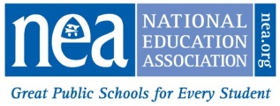
2025 Friend of Education
Nomination Form

I hereby submit the name of the following individual, organization, or group in nomination for the 2025 NEA Friend of Education Award.
Nominee:
Position and/or Organizational Affiliation:
Address:
City: | State: | Zip Code:
Provide a statement below indicating the reason for your nomination and summarize the nominee’s qualifications for the award. Documents and other materials supporting your nomination may be submitted with this nomination form.

Nominations submitted for the Friend of Education Award will be evaluated on the basis of their demonstrated leadership, acts, and support that have significantly contributed to the advancement of public education, education employees, and/or students on a national level.
Statement:

Nominating member or affiliate:

Signature of nominator or affiliate officer (Digital signature accepted):
Name of local affiliate, if a member:

Address:

City: | State: | Zip Code:
Nominator’s telephone number:
Please email the completed form, with any attachments, to Tina Paden (tpaden@nea.org). Subject: NEA Friend of Education Award Committee. The deadline for receipt of the nomination form is January 24, 2025.

