Affiliate Syndication Instructions
NEA Affiliates currently on the NEA platform now have the ability to syndicate content directly from nea.org
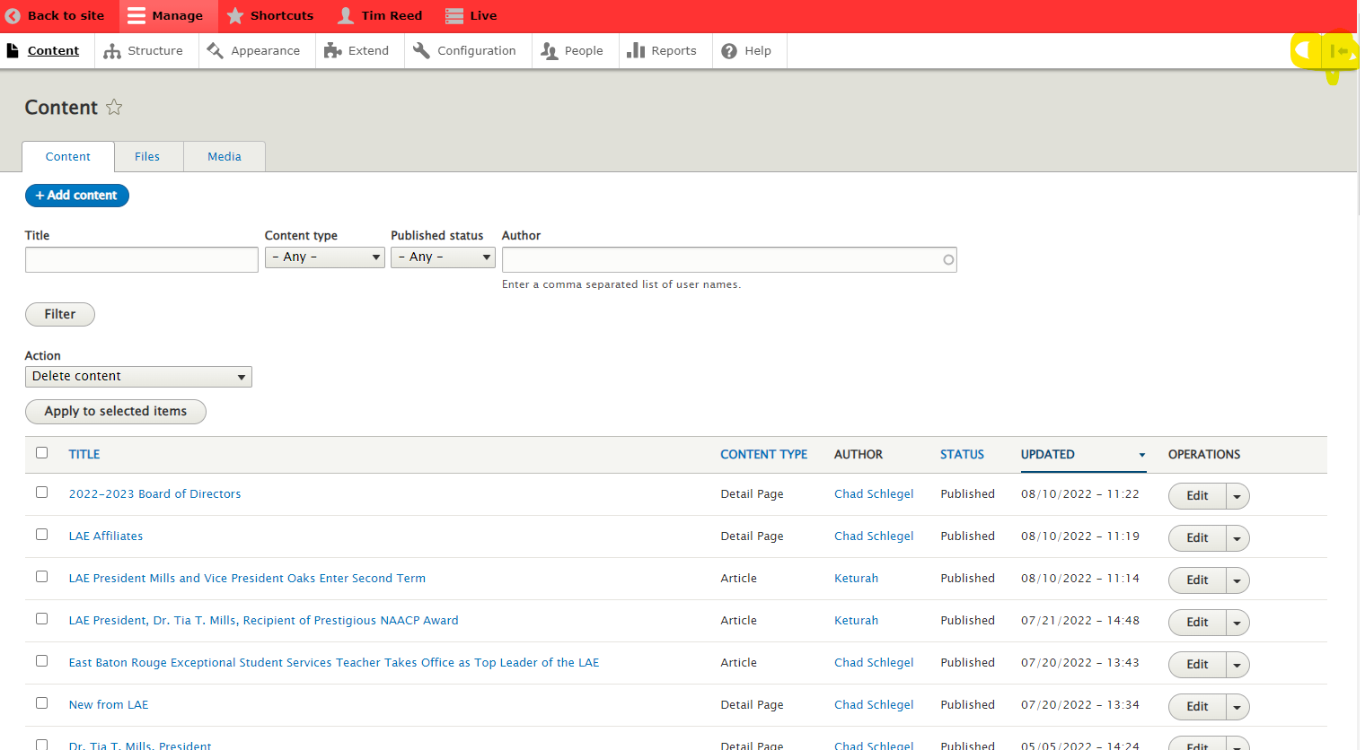
- Start by clicking the button on the top right of your editor menu to expand your menu to the left hand side of the screen.
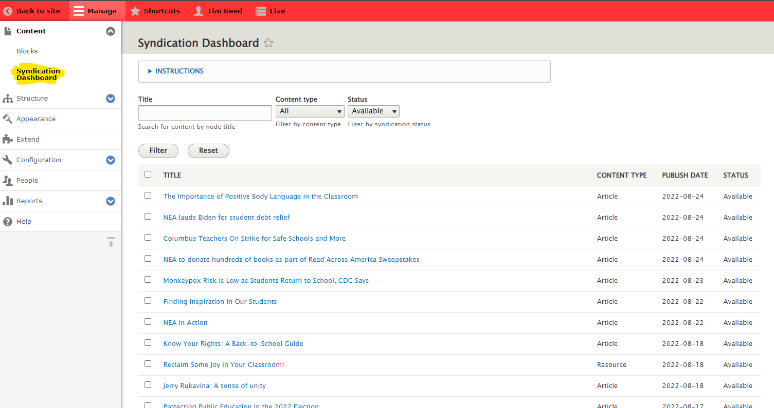
- With the menu expanded, you will see “Syndication Dashboard” as an option below “Content.” This is where you will see all the content that is available for you to syndicate and what type of content it is. Clicking on any of the items will take you to nea.org where you can preview the content before deciding if it is worth syndicating.
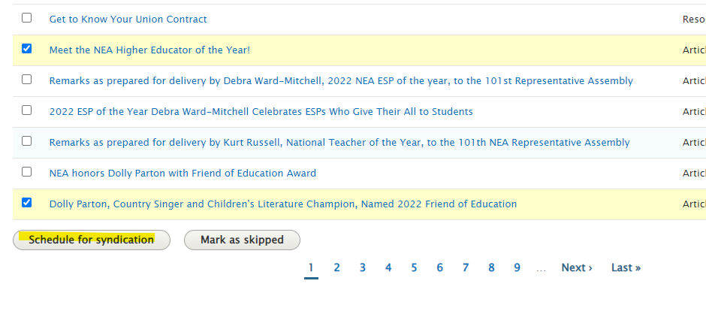
- Click the checkbox next to any content you would like to syndicate and select “Schedule for syndication.” You also have the option to “mark as skipped” which will remove the piece of content from the list. You can useful for organizational purposes.
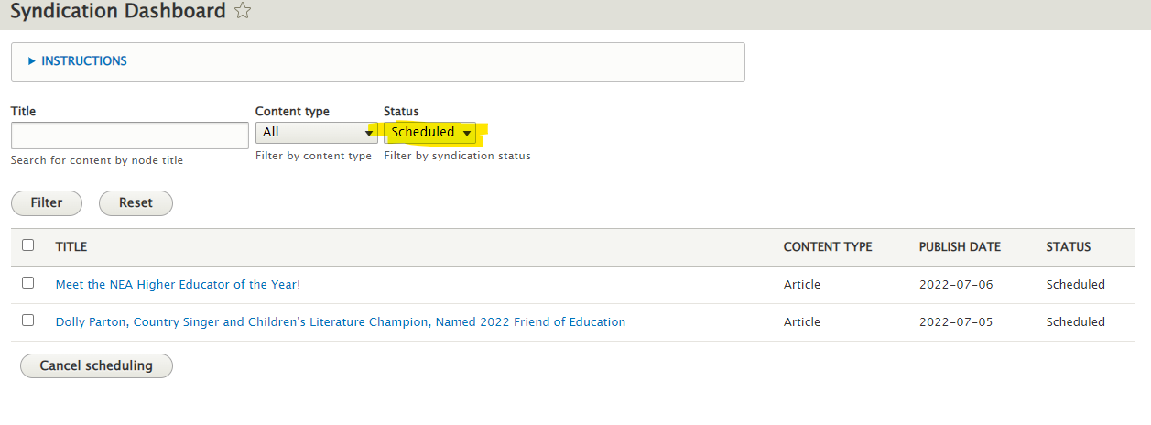
- The syndication process runs once per night, so your new content will not show up until the following day. However, you can change the filter at the top of your syndication dashboard to “scheduled” to check on anything that is in the queue to syndicate. And cancel the process if you would like.
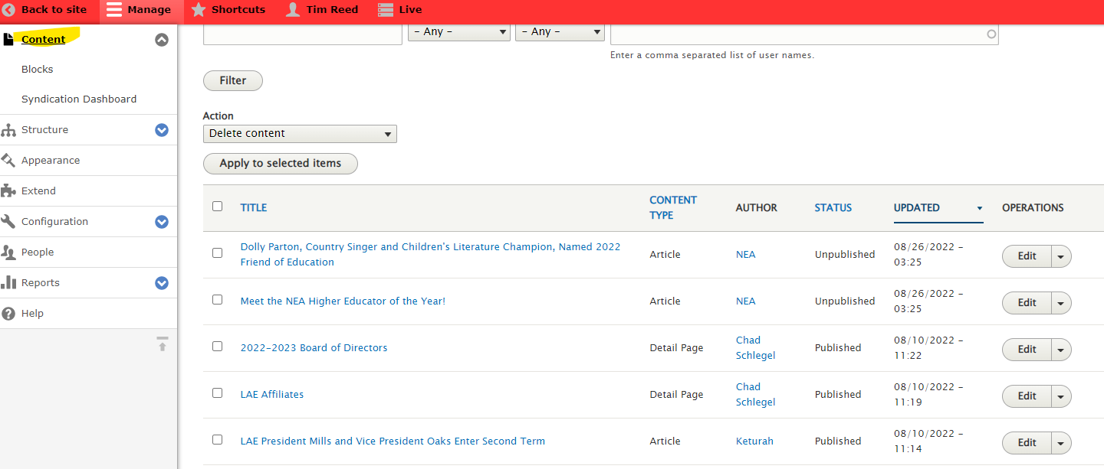
- The following morning, your new content will be at the top of your regular “Content” dashboard. The content will be unpublished, and you’ll see the author listed as NEA.
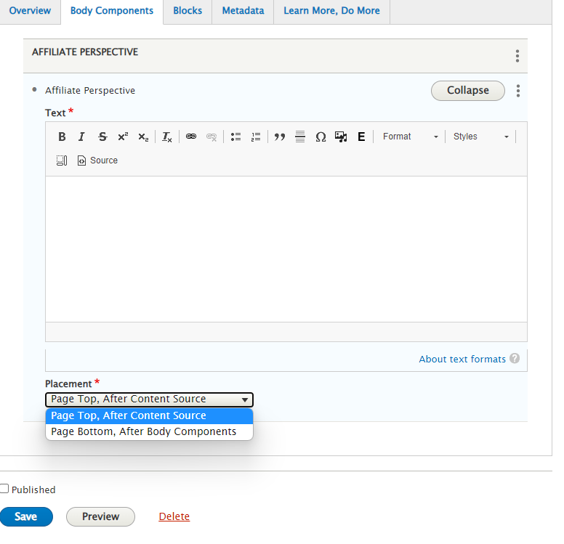
- Although you will not have the ability to edit the text of the content. You can choose to change the metadata, where you would like it to appear on your site, and you can add an “affiliate perspective” in the “Body Components” tab and decide whether you would like it to appear at the top or bottom of the page. This is a great place to call out statistics about your own state, add a quote from a member, or link to resources on your own site.

- Above you can see an article that was syndicated onto the Louisiana site. Note NEA banner and the affiliate perspective.

