
Stabilizing Inflation in Uncertain Times: What Does it Mean for Academe?
Prepared by Abby Miller and Sue Clery, ASA Research, February 2025

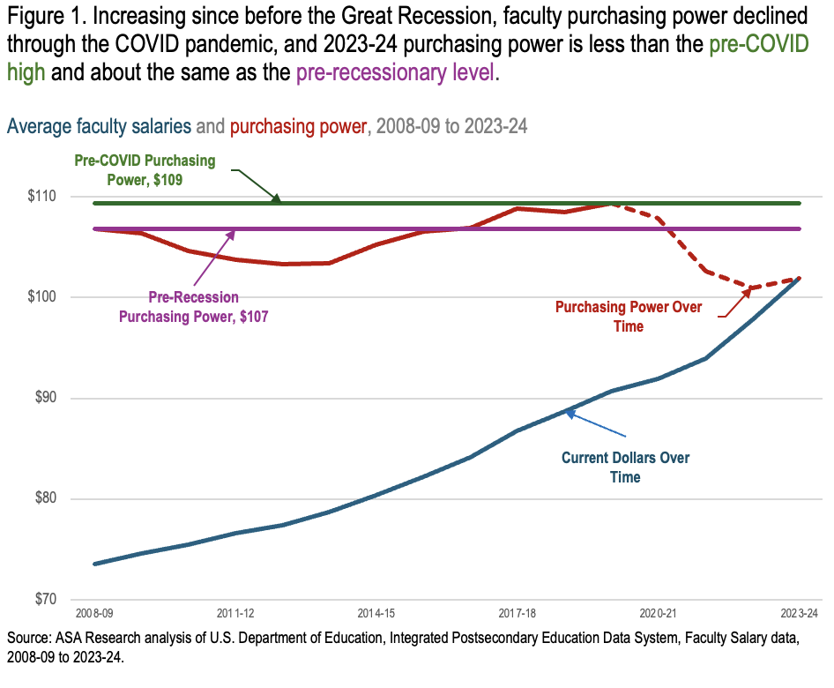
Faculty purchasing power reached a historic high in 2008-09 at the onset of the Great Recession. It declined during the recession and recovery years but later rebounded, reaching another peak just before the pandemic. However, pandemic-era inflation caused a significant drop in faculty purchasing power, bringing it well below both pre-recession and pre-pandemic levels. The inflation surge of the early 2020s led to a 7.7 percent decline in faculty purchasing power between 2019-20 and 2022-23 (Figure 1).
This year’s annual update on faculty salaries for the 2023-24 academic year shows encouraging progress. After the sharp decline in purchasing power during the COVID era, inflation has slowed and stabilized in recent years. Faculty salaries rose by an average of 4.3 percent between 2022-23 and 2023-24, exceeding the 3.3 percent inflation rate. As a result, faculty purchasing power increased by 1 percent over the year. Despite this improvement, purchasing power in 2023-24 was 6.8 percent below pre-pandemic levels. Future years’ salary increases must continue to outpace inflation for purchasing power to fully recover; otherwise, faculty purchasing power will continue to erode.
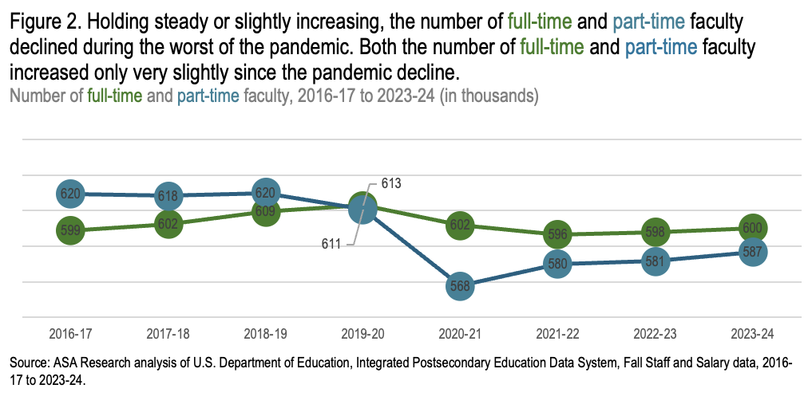
Faculty not only experienced a decline in purchasing power but also faced job losses. The first full academic year of the pandemic brought furloughs and layoffs, resulting in a 2 percent decline in full-time faculty and a 7 percent decline in part-time faculty between 2019-20 and 2020-21 (Figure 2). Since then, faculty numbers have fluctuated slightly, and as of 2023-24, full-time faculty positions remain 2 percent below pre-pandemic levels, while part-time faculty positions have seen modest increases but are still 4 percent below pre-pandemic levels.
This report analyzes trends in faculty salaries for the 2023-24 academic year, examining differences by rank, gender, institution type, sector, and collective bargaining status. A review of the economic impact on academia during 2024-25 will be available in early 2026.

Faculty: Where They Teach, and How They Distribute Across Ranks and Tenure
In 2023-24, a total of 600,098 full-time faculty were employed across 2,942 public and private nonprofit colleges and universities nationwide. While this reflects an increase of 2,095 faculty members from 2022-23, the growth remains under 1 percent. At the same time, student enrollment rose by 2.5 percent between fall 2022 and fall 2023.
The distribution of faculty by rank and institution type has remained steady, as it has for decades. In 2023-24, 7-in-10 faculty taught in public institutions (69 percent), with nearly half in public research universities and one-fifth in community colleges (Figure 3); just over one-fifth taught in private research universities. The remaining 15 percent of faculty are spread across public and private baccalaureate and comprehensive institutions, and private 2-year institutions.
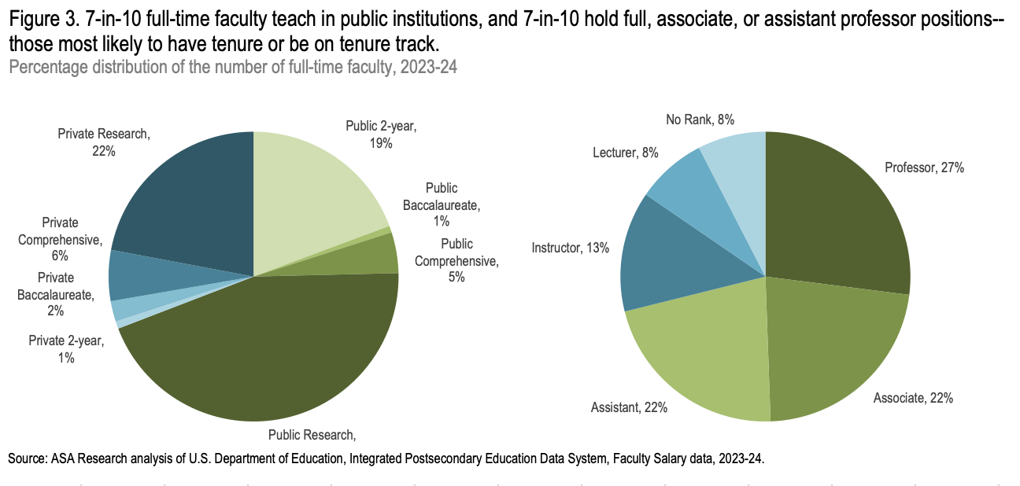
By rank, more than 7 in 10 faculty members (71 percent) were full, associate, or assistant professors—those most likely to have tenure or be on the tenure track. Among them, 27 percent were full professors, while 22 percent were assistant or associate professors. Nearly half of the remaining 29 percent of faculty were instructors, 13 percent, while 8 percent were lecturers and another 8 percent held faculty positions with no rank.
Also remaining consistent over time, the majority of faculty (83 percent) taught with 9/10-month contracts; the remaining share worked on 11/12-month contracts. Note that the distributions in Figure 3 reflect only full-time faculty. Overall, faculty were nearly evenly split between full-time (51 percent) and part-time (49 percent) positions.
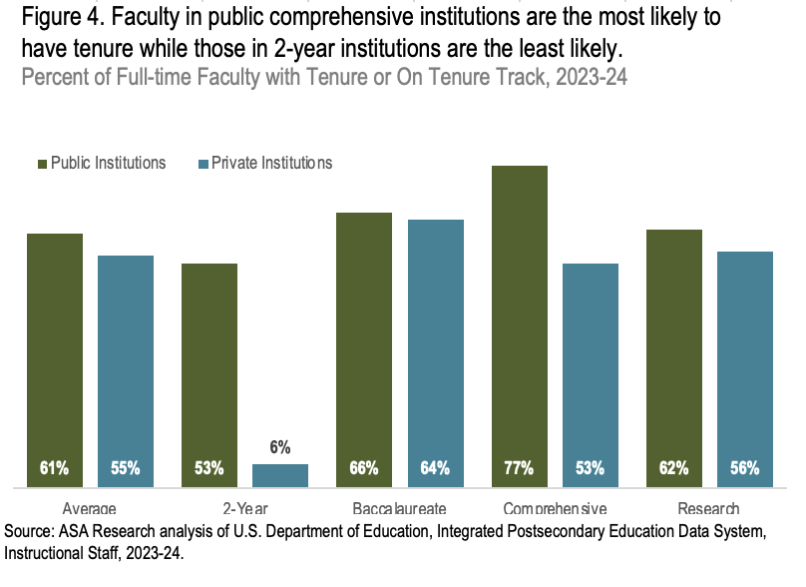
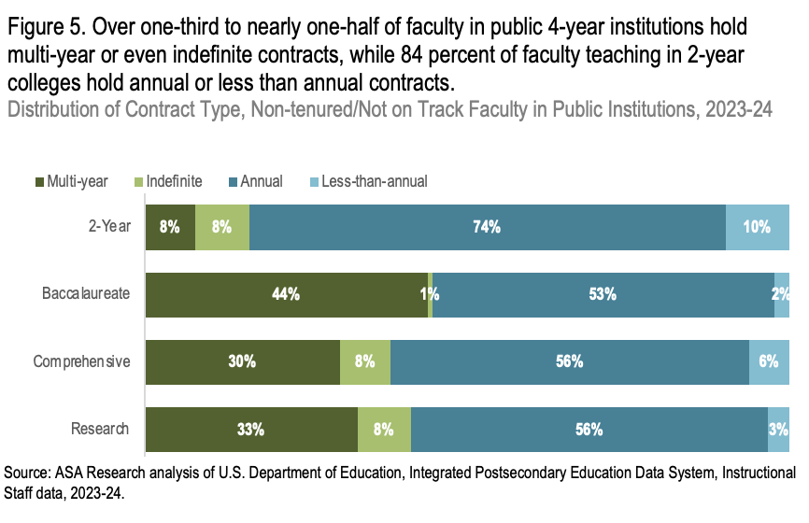
On average, 61 percent of faculty teaching in public institutions and 55 percent in private institutions had tenure or were on tenure track (Figure 4). Faculty in public comprehensive institutions were the most likely to have tenure or be on track, over three-quarters (77 percent). Two-thirds of faculty (66 percent) in public baccalaureate and 62 percent in public research universities had tenure or were on track. Among public institutions, community college faculty were the least likely to have tenure or be on track, 53 percent. (See Figure 4.) Among private 4-year institutions, faculty in baccalaureate institutions were the most likely to have tenure or be on track, 64 percent. Fewer faculty in private comprehensive or research universities had tenure or were on track compared with their colleagues in the public sector. Notably, only 6 percent of faculty had tenure or were on track in the private 2-year sector, but this sector accounted for just 1 percent of institutions.
Faculty working without tenure and not on tenure track hold a variety of different types of contracts—multi-year, indefinite, annual, or less-than-annual contracts. Non-tenured faculty in public 4-year institutions were 4 to 5 times more likely than those in community colleges to hold multi-year contracts (Figure 5). Annual contracts were the most frequent, regardless of institution level, but three-quarters of community college faculty held annual contracts compared to about half of non-tenured faculty in 4-year institutions. About 1-in-10 non-tenured faculty at community colleges had contracts shorter than a year, while 6 percent or fewer faculty at 4-year institutions had such contracts. Except in public baccalaureate institutions (1 percent of faculty), 8 percent of non-tenured faculty were employed with indefinite contracts.

Faculty Salaries, 2023-2024
No one is a stranger to COVID-era inflation. The cost of food, services, clothing, entertainment, housing – virtually everything – has increased noticeably. Nearly everyone, regardless of profession, has been affected by the high inflation rate and has experienced a decrease in purchasing power, or inflation-adjusted earnings.
Employers across the country raised salaries by 3.8 percent in 2024, a rate slightly higher than inflation (3.3 percent). Faculty working on 9/10-month contracts salaries also saw a salary increase of 4.2 percent, on average, and the average salary for faculty on 9/10-month contracts in 2023-24 was $101,955 (Figure 6). With 3.3 percent inflation, purchasing power rose by about 1 percent between 2022-23 and 2023-24 and faculty felt an effective average gain of $992. Across all faculty ranks, purchasing power increased over the last year, from less than one percent for full, associate, and assistant professors, to 2.8 percent for instructors, 2.6 percent for faculty with no rank, and 1.4 percent of lecturers.
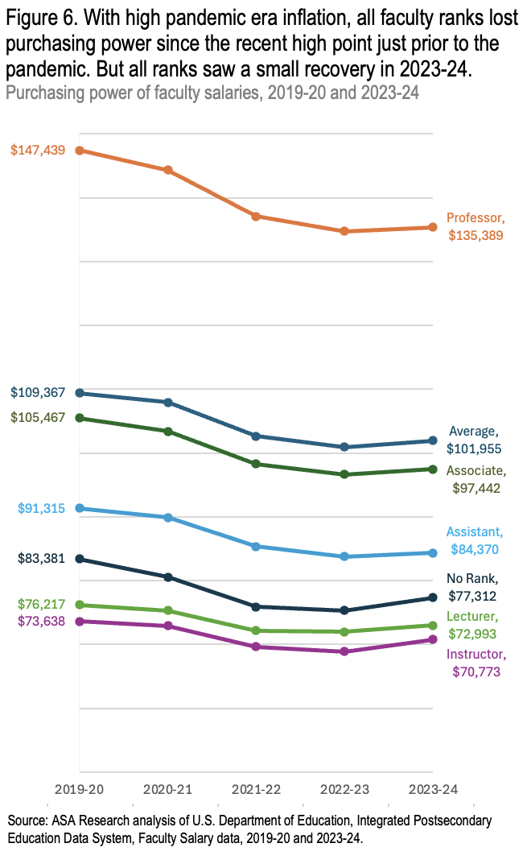
Faculty purchasing power was at a historical high in the 2019-20 academic year. Even though salaries increased in nominal dollars between 2019-20 and 2023-24, the high inflation in the early 2020s resulted in all faculty ranks losing significant purchasing power. Professors experienced the largest losses, both in magnitude (over $12,000) and percentage (8 percent); associate and assistant professors also saw an 8 percent decrease in purchasing power, losing about $8,000 and $7,000, respectively. Faculty teaching with no rank lost 7 percent (about $2,000), while instructors and lecturers each experienced 4 percent declines ($2,000 and $1,000, respectively).
Sector and Academic Rank. Salary is correlated with academic rank: in the public sector, historically, associate professors earned about three-quarters of full professors’ earnings, assistant professors earned about two-thirds, and instructors, lecturers, and faculty with no rank earn slightly more than one-half. These trends continued in 2023-24, with professors at public institutions earning an average of about $127,000, associates earning $95,000, assistants earning $83,000, and instructors, lecturers, and faculty without rank all earning similar averages of around $70,000 (Figure 7). In the private sector, due to the very high earnings of full professors, the ratios are a bit smaller.
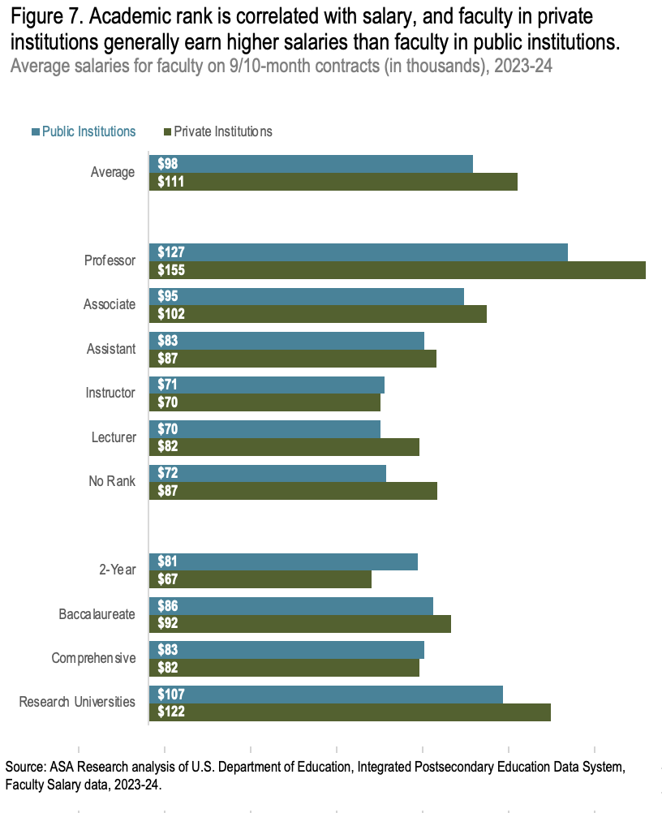
Institution level also makes a difference. Faculty teaching in community colleges earned about 76 cents to the dollar of faculty in public research universities; those in public comprehensive and baccalaureate institutions earned 78 to 80 cents to the dollar earned by faculty in research universities. These relative earnings levels have persisted over time as well.
On average, faculty teaching in private institutions earned more than those in public institutions, $111,000 compared with $98,000, for a $13,000 difference in 2023-24. This differential has persisted over time. At public institutions, instructors and those teaching in comprehensive institutions had a very slight advantage over those in private institutions. Due to the high earnings in the professorial rank, private institution professors’ earnings were about $28,000 higher than those in public institutions, for a 22 percent difference. Faculty with no rank in private institutions also had a 22 percent advantage over those in public.
By institution type, faculty in research universities at private institutions had a $15,000, or 14 percent, earnings advantage over those in public universities. Faculty at public two-year colleges had a salary advantage, earning 17 percent more than their counterparts at private institutions. However, the private two-year sector is very small, comprising only 1 percent of faculty. Faculty teaching at public comprehensive institutions had a slight salary advantage, earning 2 percent more on average than their counterparts at private institutions.
The Gender Wage Gap Persists. Nationally, women earned 84 cents to a man’s dollar earned in 2023. It is slightly better in academe, where, on average, women teaching in public institutions earned 86 cents to a man’s dollar earned. Where women teach and their faculty rank makes a difference. Women earned 96 to 98 percent of men’s earnings in community colleges; notably, community college faculty are the lowest paid among public institutions (Figure 8). Interestingly, on average, women only earned 84 percent of men’s earnings at research universities, but women professors in the sector earned 89 percent of men’s earnings.
Contributing to the wage gap is the fact that women are more likely to teach in lower-paid institutions and hold positions in lower-paid ranks. Women comprised 49 percent of all faculty but were over-represented in all ranks of community colleges, where they were 53 to 57 percent of faculty (Figure 9).
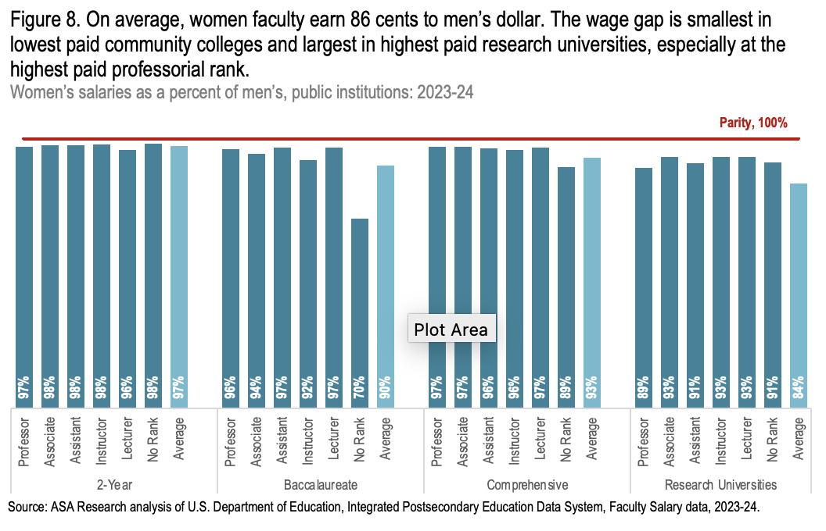
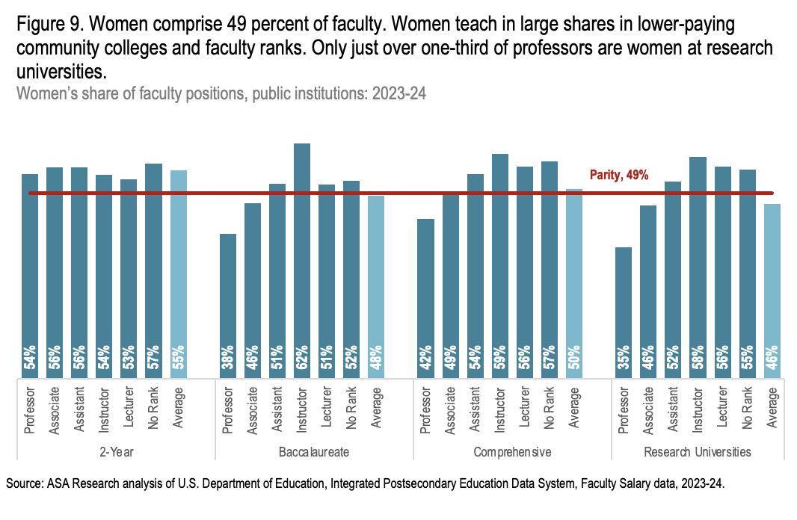
Women were underrepresented in the highest-paid ranks in the highest-paid public institutions: women comprised only 35 and 46 percent of professors and associate professors at research universities, and across all types of 4-year institutions, women were underrepresented in the highest-paid professorial ranks.
What’s Happening within States? Regional, state, and local economies, as well as politics, have a significant impact on faculty salaries. Institutional enrollment, the demand for specific programs, faculty and staff unions, and numerous other factors also play a role. Also, the recent period of high inflation has put pressure on state and institutional revenues, priorities, and budgets. How do these factors influence faculty salaries in different states?
The national average in public 4-year institutions was over $100,000 for the second year in a row, $104,439. The states that historically vie for the top ranks remain in the top five in 2023-24—California, New Jersey, Delaware, Hawaii, and Connecticut (Table 1). California was the perennial leader for the sector, and faculty teaching in California’s public 4-year institutions had an average salary of $133,447. This was a 3.4 percent increase over 2022-23, which is just above the rate of inflation. New Jersey ranked 2nd and had an average salary of $129,661, which was $3,786 less than California.
Half of the states (25) paid public 4-year faculty salaries over $100,000 in 2023-24; this is up from eighteen states the prior year. In 32 states, public 4-year faculty salaries increased at rates higher than the inflation rate between the 2022-23 and 2023-24 academic years. With salaries from $78,000 to $79,520, Mississippi, Arkansas, and Louisiana remain at the bottom of the rankings as they have for years; however, the cost of living in these states is significantly lower than in other states. Notably, of these three states, only Louisiana’s salaries increased at a rate above inflation, 4.6 percent; Arkansas and Mississippi faculty salaries increased by 2.0 and 1.8 percent, respectively.
For the third year, California is the only state where community college faculty earned over $100,000 ($120,768) and leads the salary ranking in the community college sector in addition to the 4-year sector. California’s community college faculty also saw a large increase of 9.2 percent in their salaries, on average. Three states paid their community college faculty average salaries between $90,000 and $100,000 in 2023-24: Connecticut ($93,555), Michigan ($91,022), and New York ($90,443). Arkansas historically trails the ranks, with an average salary of $53,917 in the community college sector for 2023-24. This was followed closely by Kentucky, West Virginia, Louisiana, Mississippi, Indiana, South Carolina, Montana and North Carolina, all under $60,000. Community college faculty in 28 states saw increases in salaries above the inflation rate and some of these states’ increases were significant, for example, 13 percent in Oklahoma, 12 percent in Nevada, and between 9 and 10 percent in New Mexico, Washington, and California.
At private institutions, faculty in New Jersey earned the most among states in 2023-24 ($141,158), unseating Massachusetts which had been the sector leader for some time. Nine states – New Jersey, Massachusetts, Connecticut, California, New Hampshire, Rhode Island, New York, and Maryland, along with Washington, D.C., paid private institution faculty an average over $120,000. Ranked 6th, Washington, D.C.’s average faculty salary at private institutions was $128,763, but public 4-year institutions’ salaries rank 46th, $83,630.
The pay differential between faculty at 2-year and 4-year public institutions varies by state. In 2023-24, the average salary difference between these faculty groups across states was $23,126. In five states, faculty teaching in public 4-year institutions earned over $40,000 more than their colleagues in community colleges: Delaware, Florida, Iowa, Indiana, and New Jersey. New Jersey and Indiana had the largest average salary difference, $45,513 and $44,761, respectively.
Although salaries were quite disparate, some states’ salary rankings were similar in the two sectors; for example, California’s average faculty salaries ranked 1st in both 2- and 4-year public institutions, but the dollar difference was over $12,000. Conversely, some states’ rankings for 2- and 4-year institutions differed by a fair magnitude, yet the average salary in the two sectors differs only slightly. In Wisconsin, the difference was over $10,000, and the 2-year and 4-year ranks were 6th and 26th, respectively. In seven states, the differential was less than $20,000.
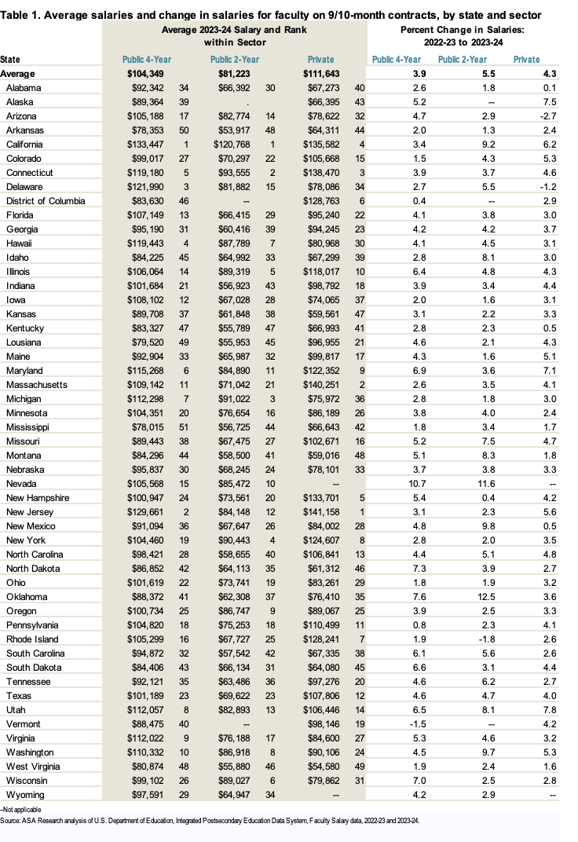
The average salaries for faculty teaching in public 2- and 4-year institutions increased 5.5 and 3.9 percent between 2022-23 and 2023-24, respectively, and salaries in private institutions increased 4.3 percent – all above inflation – so, on average, purchasing power increased between the two years in all three sectors. Faculty in public 4-year institutions in Vermont saw a decrease in the average salary, as did community college faculty in Rhode Island and faculty at private institutions in Arizona and Delaware. Note that these declines may be due to a change in the mix of faculty by rank and/or discipline and does not necessarily mean that individuals’ salaries declined.
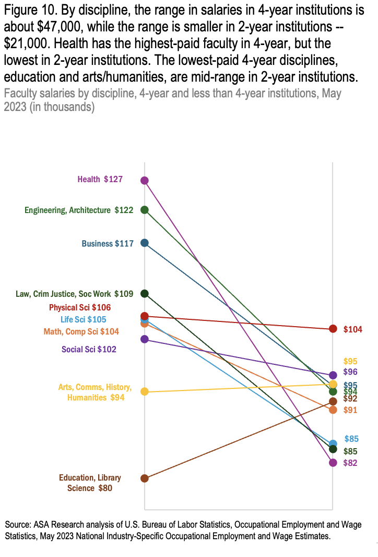
Differences by Discipline. What is taught and where it is taught matter. Interestingly, some of the highest-paid disciplines in 4-year institutions were the lowest-paid in 2-year, and vice versa. For example, faculty teaching in health fields in 4-year institutions had the highest earnings by discipline in 2023-24, averaging about $127,000, yet health faculty were the lowest-paid in 2-year institutions, $82,000 (Figure 10). On the other hand, education and library science faculty were among the lowest-paid in 4-year institutions, $80,000, but at an average of $92,000, were mid-range at 2-year colleges. Physical science faculty were the highest-paid at 2-year colleges, earning an average of $104,000. At 4-year institutions, while they earned an average of $106,000, this salary falls in the mid-range compared to other disciplines at 4-year institutions. Salaries of faculty teaching engineering and architecture, and business ranked 2nd and 3rd in 4-year institutions, but were in the mid-range at 2-year institutions. In 2023-24, only arts, communications, history, humanities, and education and library science faculty earned more in 2-year colleges than their colleagues teaching in 4-year colleges.
The range in salaries by discipline was three times larger at 4-year institutions compared to 2-year colleges. At 4-year institutions, salaries ranged from a high of $127,000 for health faculty to a low of $80,000 for education and library science faculty, a range of $47,000. In contrast, 2-year college faculty salaries had a much narrower range of $22,000, with physical science faculty earning a high of $104,000 and health faculty earning a low of $82,000.
The Union Advantage. Research shows that strong labor unions support middle-class workers and help to ensure a robust economy. And, unions are found to address worker challenges, such as flat wages, high housing prices, and help to improve intergenerational mobility. “… Middle-class workers reap substantial benefits from unionization. Unions raise the wages of their members by 10 to 15 percent. Unions also improve fringe benefits and workplace procedures such as retirement plans, workplace grievance policies, and predictable scheduling.” Further, unions help to reduce gender and race wage gaps. And, spillover effects work to improve wages and conditions at non-unionized industry competitors and nearby organizations and businesses.
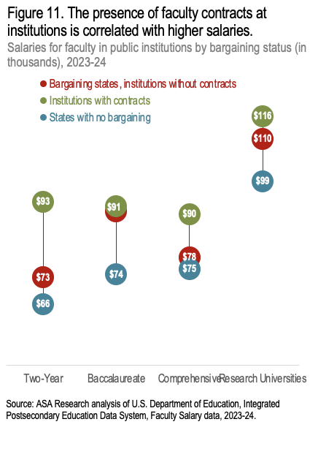
Salary analysis of the presence of unions in higher education validates the above research – regardless of institution type, faculty teaching at institutions with collective bargaining agreements earned more than others, and the difference is considerable in some cases. Figure 11 illustrates the faculty salaries for (1) institutions with faculty bargaining agreements, (2) institutions in the same states, but without faculty bargaining agreements, and (3) institutions in states where no faculty collective bargaining agreements exist in colleges and universities. Community college faculty with the presence of contracts had the largest advantage and earned, on average, about $20,000 more than their colleagues in the same states but teaching at colleges without contracts. The earnings advantage for unionized faculty in comprehensive institutions was $11,000, and $6,000 for faculty in research universities. At baccalaureate institutions—a very small sector—the earnings advantage is about $1,000.
Notably, faculty salaries in states with no collective bargaining are the lowest. This finding aligns with the notion that the presence of unions, regardless of membership, increases benefits for non-members. However, additional factors should be considered, as the states without faculty contracts may have different economies than those with collective bargaining activity. For example, these are largely southern states with lower cost of living. Faculty salaries in institutions with contracts and those in the same states, but without contracts, are the most comparable.
The HBCU Disadvantage. There are 107 Historically Black Colleges and Universities (HBCUs) in the U.S. HBCUs provide higher education via a campus climate that fosters success, and where students of color feel comfortable, supported, and safe. Although HBCUs play a crucial role in accelerating social mobility for underserved students, they do so with fewer resources, and their faculty earn less than those at non-HBCUs. Additionally, federal funding for HBCUs is now under threat due to the current presidential administration's attacks on government spending related to diversity, equity, and inclusion.

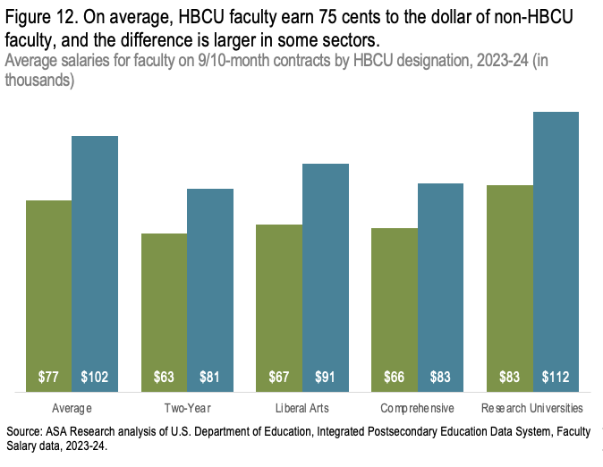
HBCU Faculty earned, on average, 75 cents to the dollar of other faculty’s earnings in 2023-24; HBCU faculty earned an average of $76,751 compared with $102,492 earned by faculty at non-HBCUs (Figure 12). The disparity is most pronounced in research universities, where HBCU faculty earned $29,000 less than their non-HBCU counterparts in 2023-24. The difference is also significant at baccalaureate institutions, where HBCU faculty earned $24,000 less.
The student environment fit is very important for student success. HBCUs have been found to “outperform non-HBCUs in student experience, affordability, and after college preparedness for Black students”.¹ HBCUs are “best value” institutions of higher education and provide quality education at 27 percent lower cost than comparable institutions.² HBCUs represent only three percent of higher education institutions but they enroll 10 percent of higher education’s African American students, produce 15 percent of the African American bachelor’s degree recipients, and 19 percent of black STEM degree recipients.^{3, 4}
Land-grant HBCUs ≠ Land-grant non-HBCUs. Faculty teaching in the HBCU land-grant institutions earn a fraction of those teaching in non-HBCU land-grants. Even when comparing faculty teaching in the same state, and thus taking different economies into account, some HBCU faculty earned just half of those teaching in non-HBCU land-grants. HBCU faculty teaching in Ohio and Missouri earned 52 and 54 cents to the dollar, compared with non-HBCU colleagues, respectively (Figure 13; Lincoln University and Central State University are the 1890 HBCU land-grant universities; University of Missouri and Ohio State University are the 1862 non-HBCU land-grants). The salary gaps are the smallest in North Carolina and Tennessee where faculty teaching at the HBCU land-grant earned 77 and 79 cents to the dollar of faculty teaching at the non-HBCU land-grant, respectively (NC Agricultural and Technical State University and Tennessee State University are the 1890 HBCU land-grant universities; University of North Carolina and University of Tennessee are the 1862 non-HBCU land-grants).
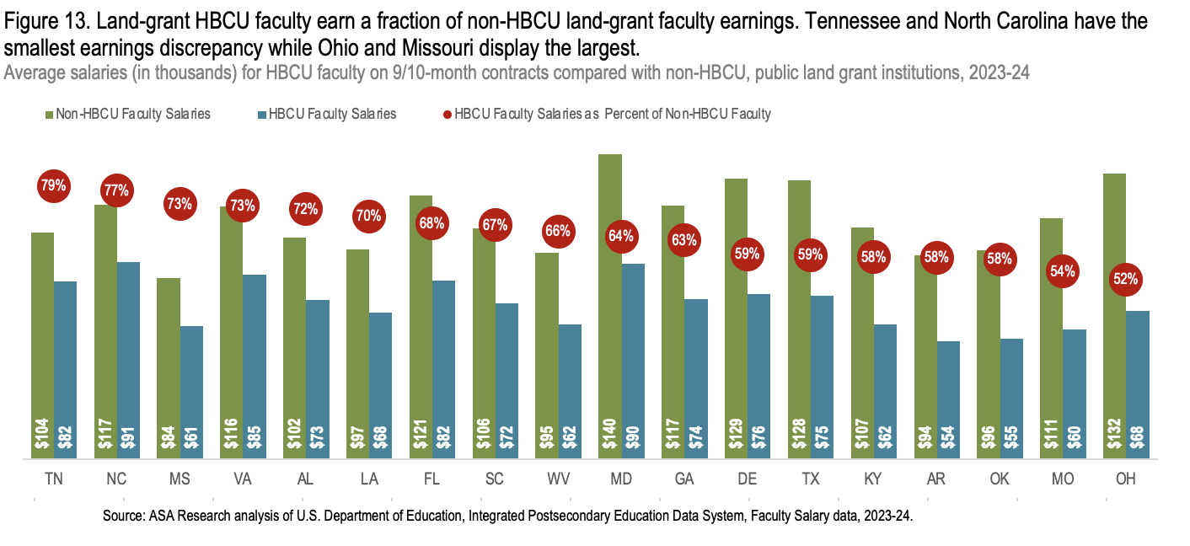
Graduate Assistant Earnings. Graduate assistants typically earn a stipend for teaching, conducting research, or working in labs. The average stipend paid to graduate assistants in 2023-24 was $21,368 (Figure 14), assuming the assistant is employed half-time. Also, although not universal, some may also receive tuition and fees waivers; the average tuition and fee waiver was $9,943. Research assistants, on average, received the largest stipend, $22,405, while graduate and teaching assistants earned about $20,000 each.
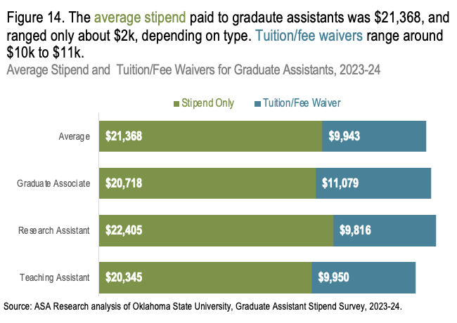
The average range of stipends paid to graduate assistants in 2023-24 was between $16,000 and $23,000 (Figure 15). The largest stipends were awarded to graduate assistants in health and English fields, where the largest stipends reached $90,000, followed by agriculture at $85,000 and social sciences at $83,000. These high-end stipends appear to be outliers, as the average stipend within each discipline was generally $20,000 or less. The smallest stipends paid in 2023-24 were $2,000, and many disciplines paid stipends under $5,000.
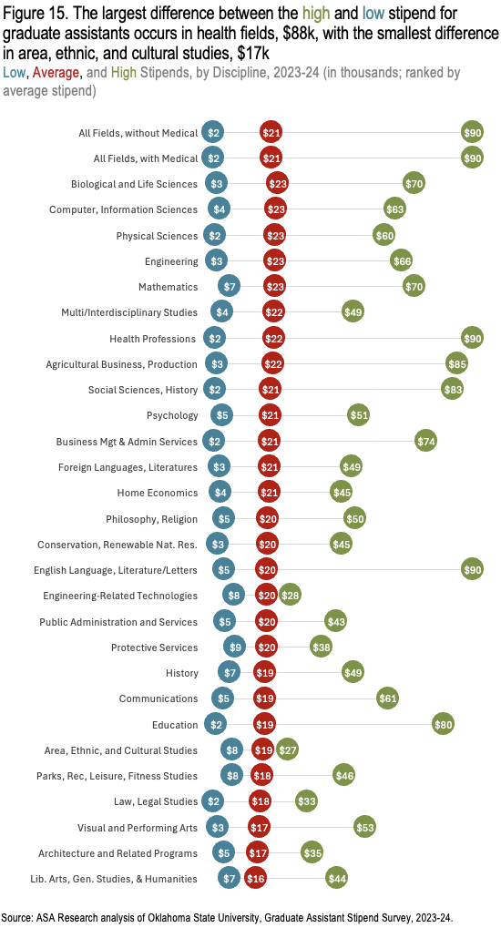

What Lies Ahead for Higher Education?
Faculty salaries in 2023-24 show promising signs of recovery from the impact of recent years’ high inflation, and institutions appear to be making progress in adjusting salaries accordingly. While some states’ budgets are relatively stable, some colleges and universities continue to struggle with budget deficits, declining enrollment, consolidations, and reorganizations – challenges that can lead to faculty furloughs and layoffs.
But the future remains uncertain not only for faculty compensation but also for faculty job security, working conditions, and the nature of their work. Higher education institutions and academia are facing mounting challenges due to the current political climate and sustained attacks on diversity, equity, and inclusion, as well as research conducted on college campuses. And, the accreditation system may also be at risk. The administration has canceled U.S. Department of Education contracts that fund higher education institutions and research and is threatening to dismantle the agency entirely, a move with far-reaching consequences for both students and educators. The U.S. Department of Education also provides the national datasets used in this report to track student and institutional progress, but the future of these data is uncertain.
Beyond political and financial pressures, technological advancements are reshaping faculty work. Artificial intelligence (AI) is emerging as a tool for both students and faculty, but questions remain about its most effective and ethical use. Additionally, shifting demands for programs and content may drive significant curriculum changes, altering course offerings and necessitating adjustments in faculty composition.
What does all of this mean for faculty salaries in 2025? Will faculty see the same salary increases in the 2024-25 academic year that helped restore purchasing power in 2023-24? How many faculty will be affected by consolidations, restructuring, and evolving program offerings? How will the political and technological landscape reshape faculty work? And, although inflation has slowed over the past year, will it remain low despite the administration’s actions, allowing faculty earnings to catch up?
DATA SOURCES
This report relies largely on U.S. Department of Education, National Center for Education Statistics (NCES), Integrated Postsecondary Education Data System (IPEDS) Human Resources data. Reflecting 2023-24, NCES gathered data from 3,818 degree-granting colleges and universities as part of the annual IPEDS data collection for higher education institutions. This analysis excluded 876 seminaries, religious training institutions, and for-profit colleges, leaving 2,942 institutions. At the time of analysis, these data include the provisional release of the IPEDS data and results may differ from data reported by NCES in the future.
This report also includes U.S. Bureau of Labor Statistics wage estimates for faculty teaching in less-than-4-year and 4-year institutions by discipline in May 2023. Wage estimates are computed with data collected from a statistical sample of institutions of all sizes, in every state and the District of Columbia.
An analysis of the Oklahoma State University’s Graduate Assistant Stipend Survey data for 2023-24 is also included; this survey includes 57 land-grant institutions and 77,706 graduate assistants.

References for text box in HBCU section:
1 --. (ND). Why choose an HBCU? HBCU First. Available: https://hbcufirst.com/resources/why-choose-an-hbcu.
² Ibid.
3 UNCF. (ND). Fact sheet: Investing in better futures for students and for all of us. Available: https://cdn.uncf.org/wp-content/uploads/2022-UNCF-Fact-Sheet8.pdf
4 Broady, K., Perry, A. M., Romer C. (August 4, 2021). “Underfunding HBCUs leads to an underrepresentation of Black faculty,” The Avenue. Brookings. Available: https://www.brookings.edu/blog/the-avenue/2021/08/04/underfunding-hbcus-leads-to-an-

Reference for land grant text box:
National Education Association. “A Looming Crisis for HBCUs? An Analysis of Funding Sources for Land Grant Universities,” NEA Research Land Grant University: Brief No. 2. Available: https://www.nea.org/resource-library/looming-crisis-hbcus.

Computation based on the 2023-24 academic year (August to July). Consumer price index data from U.S. Bureau of Labor Statistics. Available: https://www.bls.gov/regions/mid-atlantic/data/consumerpriceindexhistorical_us_table.htm.
--. (January 7, 2025). Postsecondary Enrollment Rises in Fall 2023, Marking First Increase in Over a Decade. National Center for Education Statistics, U.S. Department of Education. Available: https://nces.ed.gov/whatsnew/press_releases/1_7_2025.asp
Based on ASA Research analysis of U.S. Department of Education, Integrated Postsecondary Education Data System, Faculty Salary data, 2023-24.
--. (September 9, 2024). Infographic: US Salary Increase Budgets 2024-2025. The Conference Board. Available: https://www.conference-board.org/publications/US-Salary-Increase-chart.
ASA Research analysis of U.S. Department of Education, Integrated Postsecondary Education Data System, Faculty Salary data, 2019-20 and 2023-24.
--. (March 12, 2024). Women’s earnings were 83.6 percent of men’s in 2023. Bureau of Labor Statistics, U.S. Department of Labor, The Economics Daily. Available: https://www.bls.gov/opub/ted/2024/womens-earnings-were-83-6-percent-of-mens-in-2023.htm.
--. (August 28, 2023). Fact sheet: Treasury Department releases first-of-its-kind report on benefits of unions to the U.S. economy. U.S. Department of the Treasury. Available: https://home.treasury.gov/news/press-releases/jy1706#:~:text=Unions%20raise%20the%20wages%20of,stability%20and%20worker%20well%2Dbeing.
--. (August 2023). Labor unions and the middle class. U.S. Department of the Treasury. Available: https://home.treasury.gov/system/files/136/Labor-Unions-And-The-Middle-Class.pdf
Ibid.
--. (August 28, 2023). Fact sheet: Treasury Department releases first-of-its-kind report on benefits of unions to the U.S. economy. U.S. Department of the Treasury. Available: https://home.treasury.gov/news/press-releases/jy1706#:~:text=Unions%20raise%20the%20wages%20of,stability%20and%20worker%20well%2Dbeing.
Lomax, M. L. (ND). Six reasons HBCUs are more important than ever. UNCF. Available: https://uncf.org/the-latest/6-reasons-hbcus-are-more-important-than-ever#:~:text=HBCUs%20provide%20a%20stable%20and,needs%20to%20obtain%20college%20degrees.
https://www.insidehighered.com/news/government/politics-elections/2025/02/11/tenuous-moment-msis-hbcus-and-tcus-under-trump
Krob, K. and Kim, E. (August 30, 2023). 2024 U.S. State budgets resilient: States juggle spending pressure and slower revenue growth. Fitch Ratings. Available: https://penniur.upenn.edu/uploads/media/Fitch-2024-US-State-Budgets-Resilient-States-Juggle-Spending-Pressure-and-Slower-Revenue-Growth-10243384_1.pdf.
Nietzel, M. T. (January 1, 2024). 5 Higher education trends to watch for in 2024. Forbes. Available: https://www.forbes.com/sites/michaeltnietzel/2024/01/01/five-higher-education-trends-to-watch-for-in-2024/?sh=6c0f4c5e4fcb

